Navigating SAS Hackathon Environment

- To access RAM use the server https://hack-jmgkqptx2s.engage.sas.com/

- Navigate to Retrieval Agent Manager using  dial pad on left-upper corner and open it in a new tab

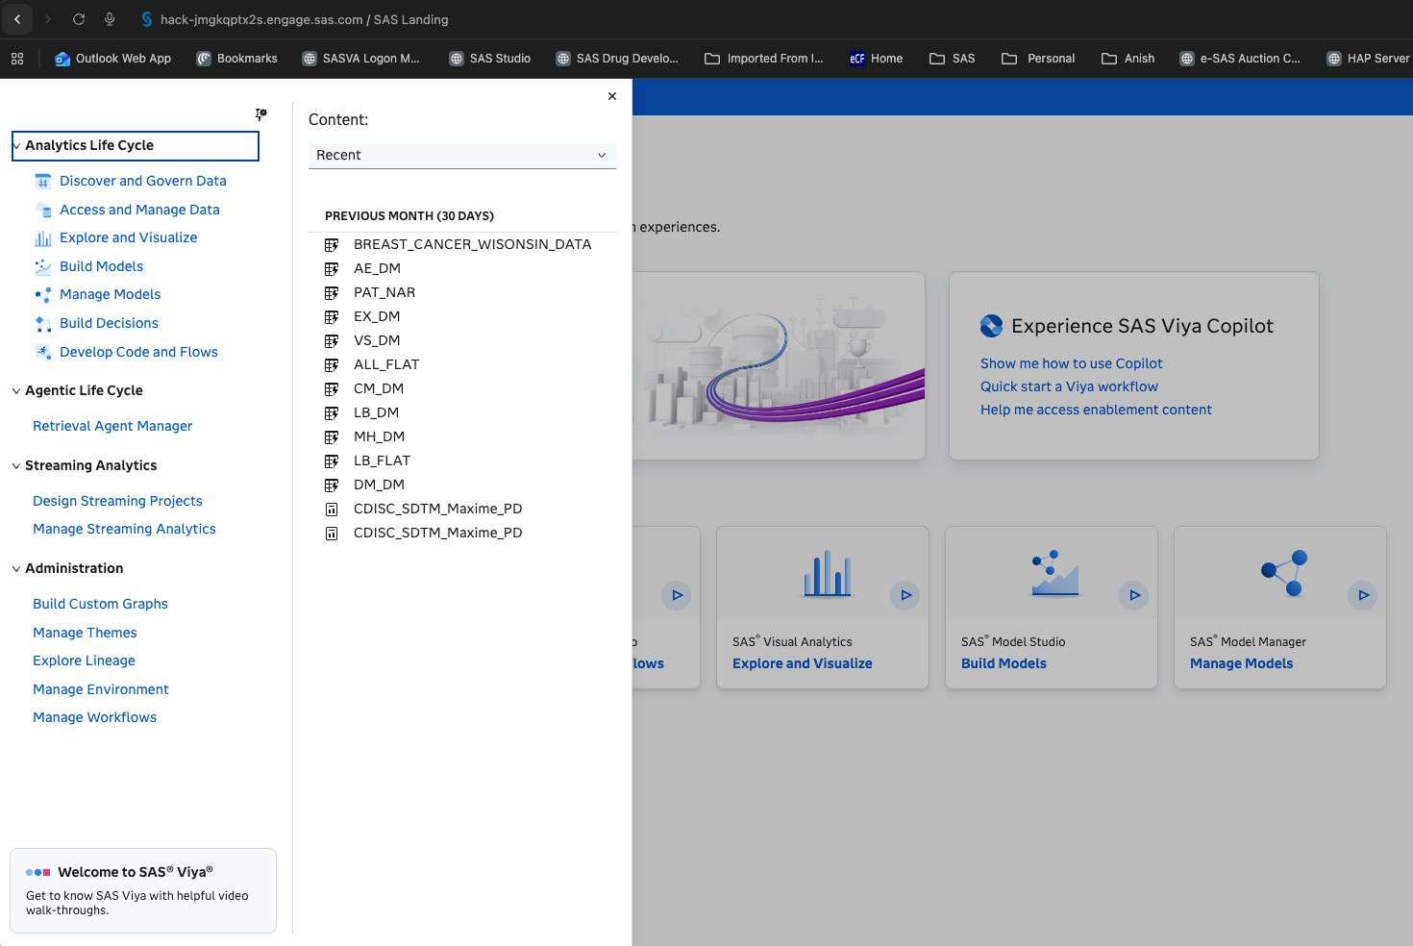
- Screen will look something like this 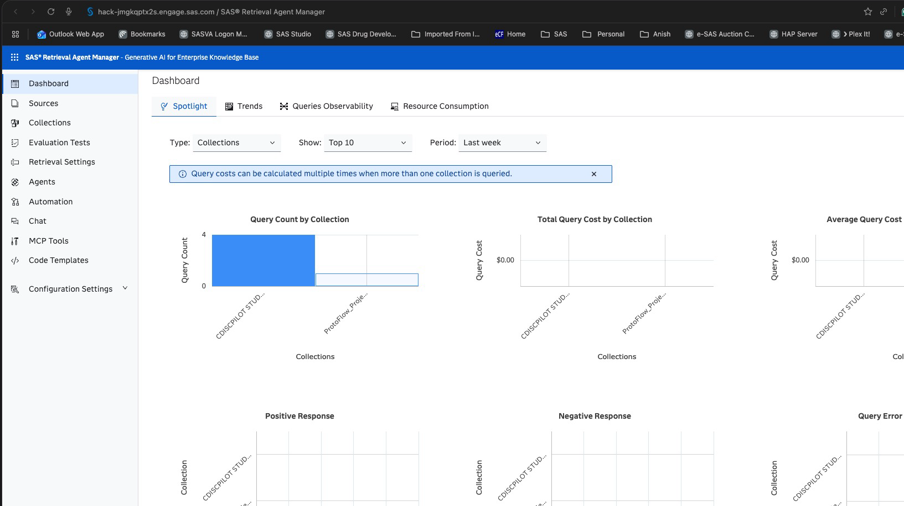
- Navigate to Sources
- Highlight and click on edit icon to go over some files 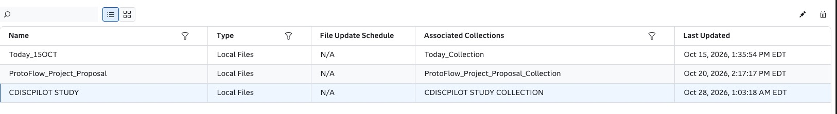
- 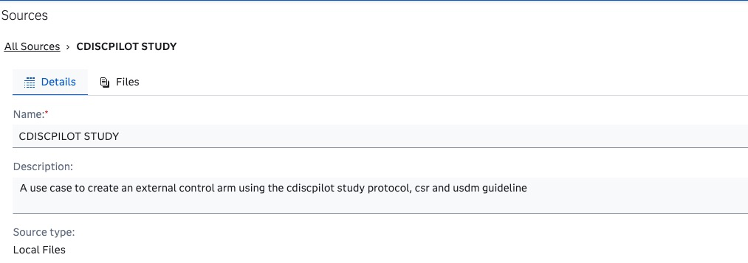
- Click on Files
- 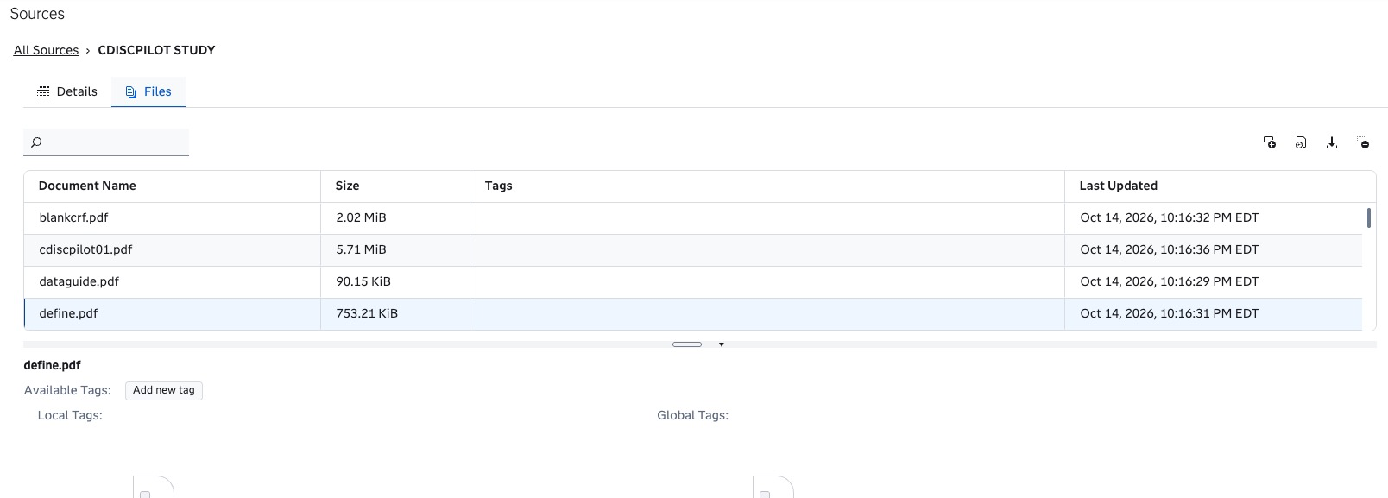
- You can upload more files or download these docs or pdf
- Go to Collections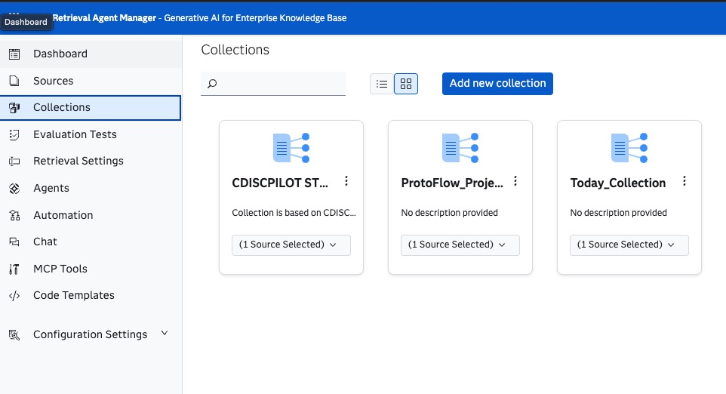
- Double click and open CDISC PILOT STUDY
- Navigate different tables like Summary, LLM, Auto Eval, User Eval, CDISCPILOT Study
  - Summary 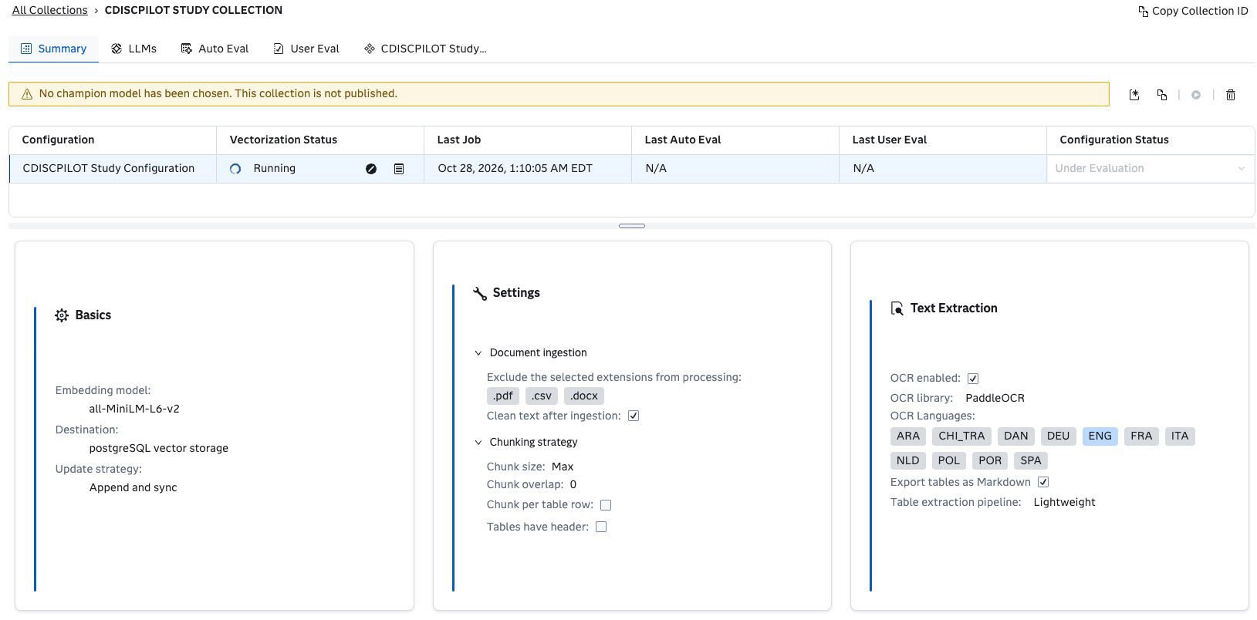
  - LLM 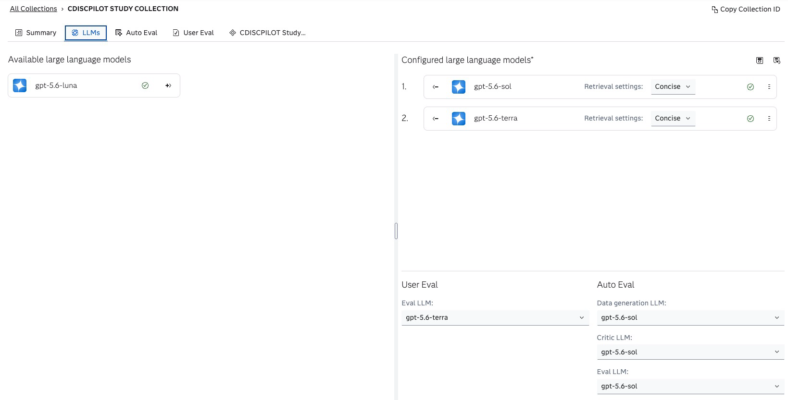
  - Skip Auto Eval, User Eval
  - CDISCPILOT STUDY Configuration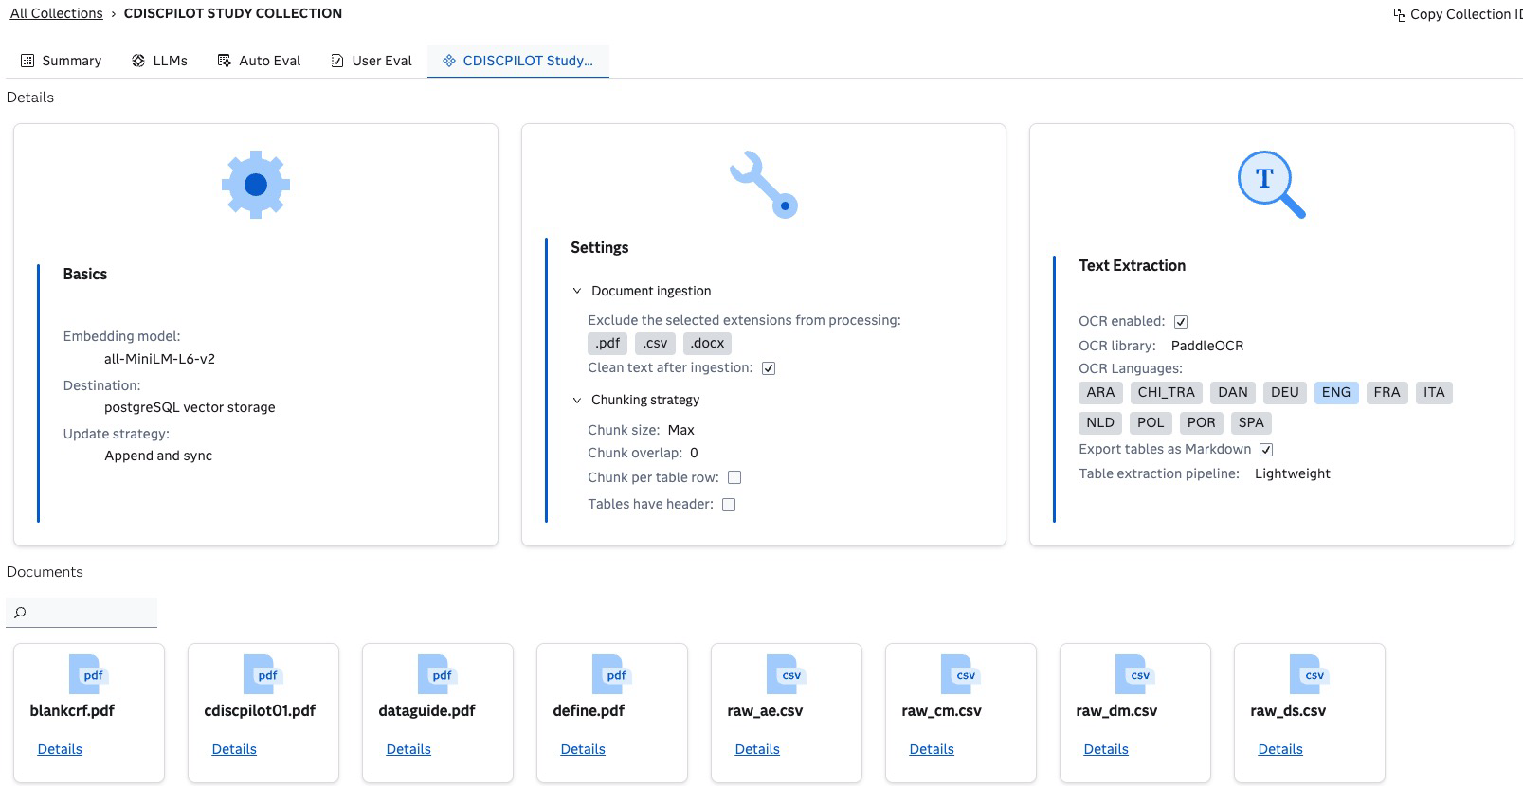
- Evaluation Tests
  - 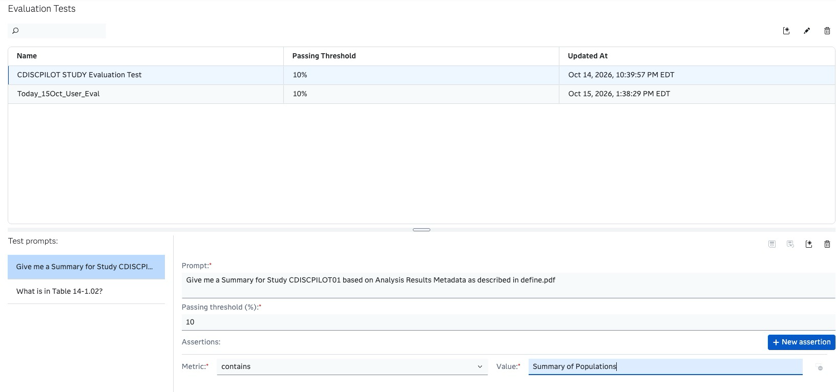
- Retrieval Settings
  - We can choose any of these settings when we chat with our RAM, it could be Concise or Summary

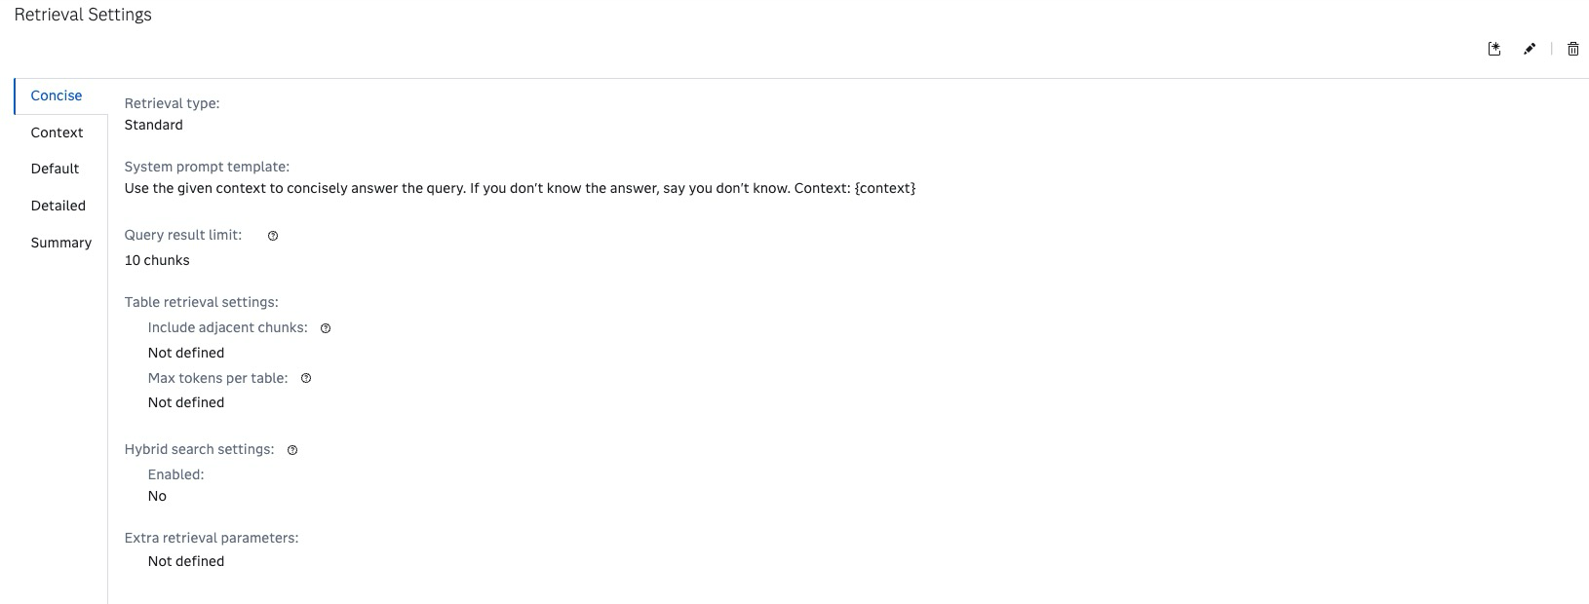
  - Skip Agents
- Automation: Gives a glimpse about how we have set up the artifacts to chat with our docs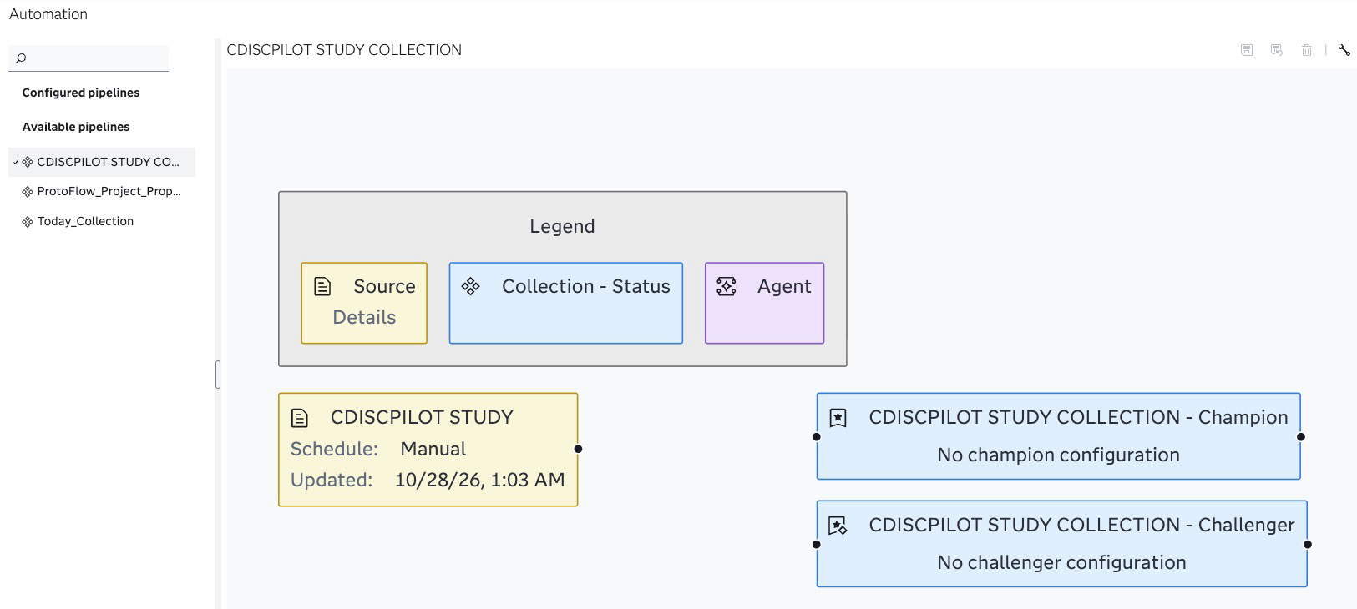
- Chat
  - Select or highlight CDISCPILOT Study Configuration 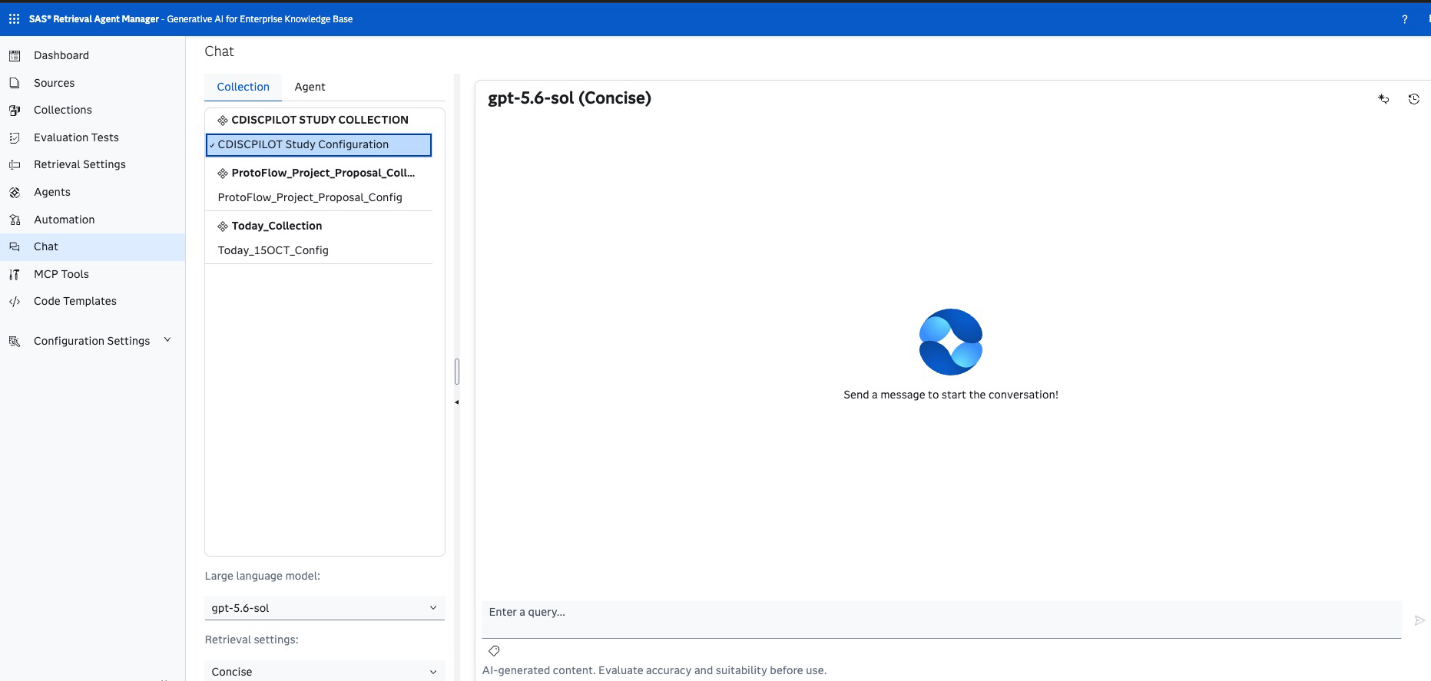
  - Start generating query e.g. “Based on the define.pdf, raw_dm.csv, blank CRF documents, please generate the specs for SDTM DM domain to convert raw_dm.csv dataset to SDTM DM Domain. Also provide the sample sas code if possible”
